# Installing Unix tools on Windows via Git Bash

Installing Git for Windows gives you convenient access to a command-line environment with common Unix tools like grep, sort, cut, or curl. 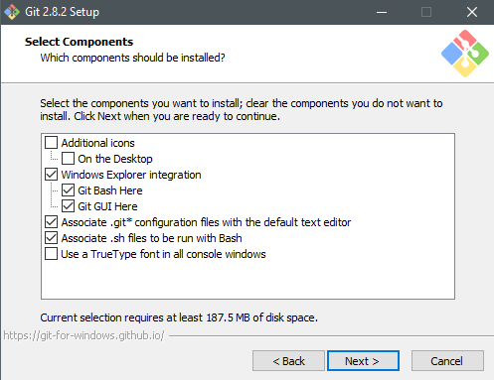

**Download the latest Windows installer from:** [**https://git-scm.com/downloads**](https://git-scm.com/downloads)

**Run the installer:**

1. **Make sure to keep “Git Bash Here” checked when setting options (shown right).**
2. **Select “Use Windows’ default console window”. (shown below)**
3. **Other options can be left as-is**

*Make sure to leave “Git Bash Here” checked*

**Click through the installer leaving everything else as its default except for this setting:**

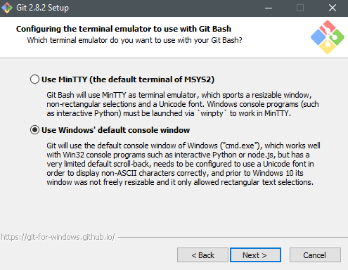*Check the second option here (shown). This is important to be able to run Python from the Git Bash*

# Opening a Bash Terminal (For Unix Commands)

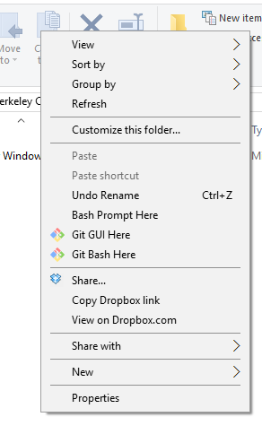

In any folder, you can have access to Unix tools by opening a bash shell.

This is easily done by right-clicking in the folder and selecting “Git Bash Here”

We’ll teach you how to use Unix commands in the Bash shell to manipulate your files.

